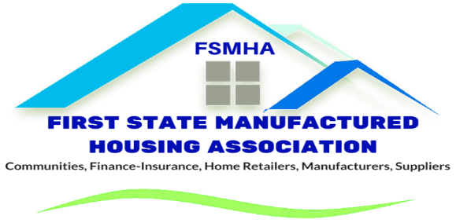

Membership Application

Join the Voice of Manufactured & Modular Housing in Delaware

Thank you for your interest in becoming a member of the First State Manufactured Housing Association (FSMHA). Membership connects you with industry leaders, advocacy efforts, professional resources, and networking opportunities that support the continued growth and success of manufactured and modular housing throughout Delaware.
Please complete all applicable sections below.

Company / Organization Name | __________________________________________
Primary Contact Name/Title | __________________________________________
Mailing Address/City/State/Zip | __________________________________________
Phone Number | ________________________________________
Email Address | __________________________________________
Website
Add’l Names for Mailing List/Title/Email

FSMHA Annual Dues Investment
Please select the category that best describes your business:
Community Owner / Operator ($5.00/site first 500 homesites, $1.50/site each additional homesite. *minimum dues $100)
Retailer / Sales Center ($250 first site, $50 each additional site)
Manufacturer ($250, plus $100 per structural floor for single, double and modular homes delivered in Delaware)
Supplier / Vendor ($250)
Finance / Insurance ($250)
Professional Services ($250)
Installer / Contractor ($250)
Other: __________________________________________

Base Dues Investment
#________Addional retailer location $_________
#________Homesites @$5/site $_________
#________Homesites @ $1.50/site $_________
Total Amount Due $_________

Community / Sales Locations
Please list all Delaware communities, branch offices, or sales locations associated with this membership.
Community / Sales Location | City / Location | Phone | Number of Homesites | Contact Person
Membership Dues Information
FSMHA membership dues are calculated on an annual basis beginning January 1 of each year. Members joining after February 1 will have their first-year dues prorated beginning on the first day of the month in which membership begins. For dues calculations or membership assistance, please contact the FSMHA Office at 302-674-5868 or email Jennifer@firststatemha.org.
Applicant Certification
I hereby apply for membership in the First State Manufactured Housing Association and agree to support the mission, objectives, and professional standards of the Association.
Authorized Signature | __________________________________________
Printed Name | __________________________________________
Title | __________________________________________
Date | __________________________________________
Payment Information
Please make checks payable to:
FSMHA
1675 S. State Street, Suite E
Dover, DE 19901

Thank You for Supporting Manufactured & Modular Housing in Delaware
We appreciate your membership and partnership with FSMHA.
For your financial and IRS reporting records, please note:
Contributions or gifts to the First State Manufactured Housing Association are not tax deductible as charitable contributions for income tax purposes. However, they may be tax deductible as ordinary and necessary business expenses subject to restrictions imposed as a result of association lobbying activities. FSMHA estimates that the nondeductible portion of your annual dues-the portion which is allocable to lobbying is 19%.

